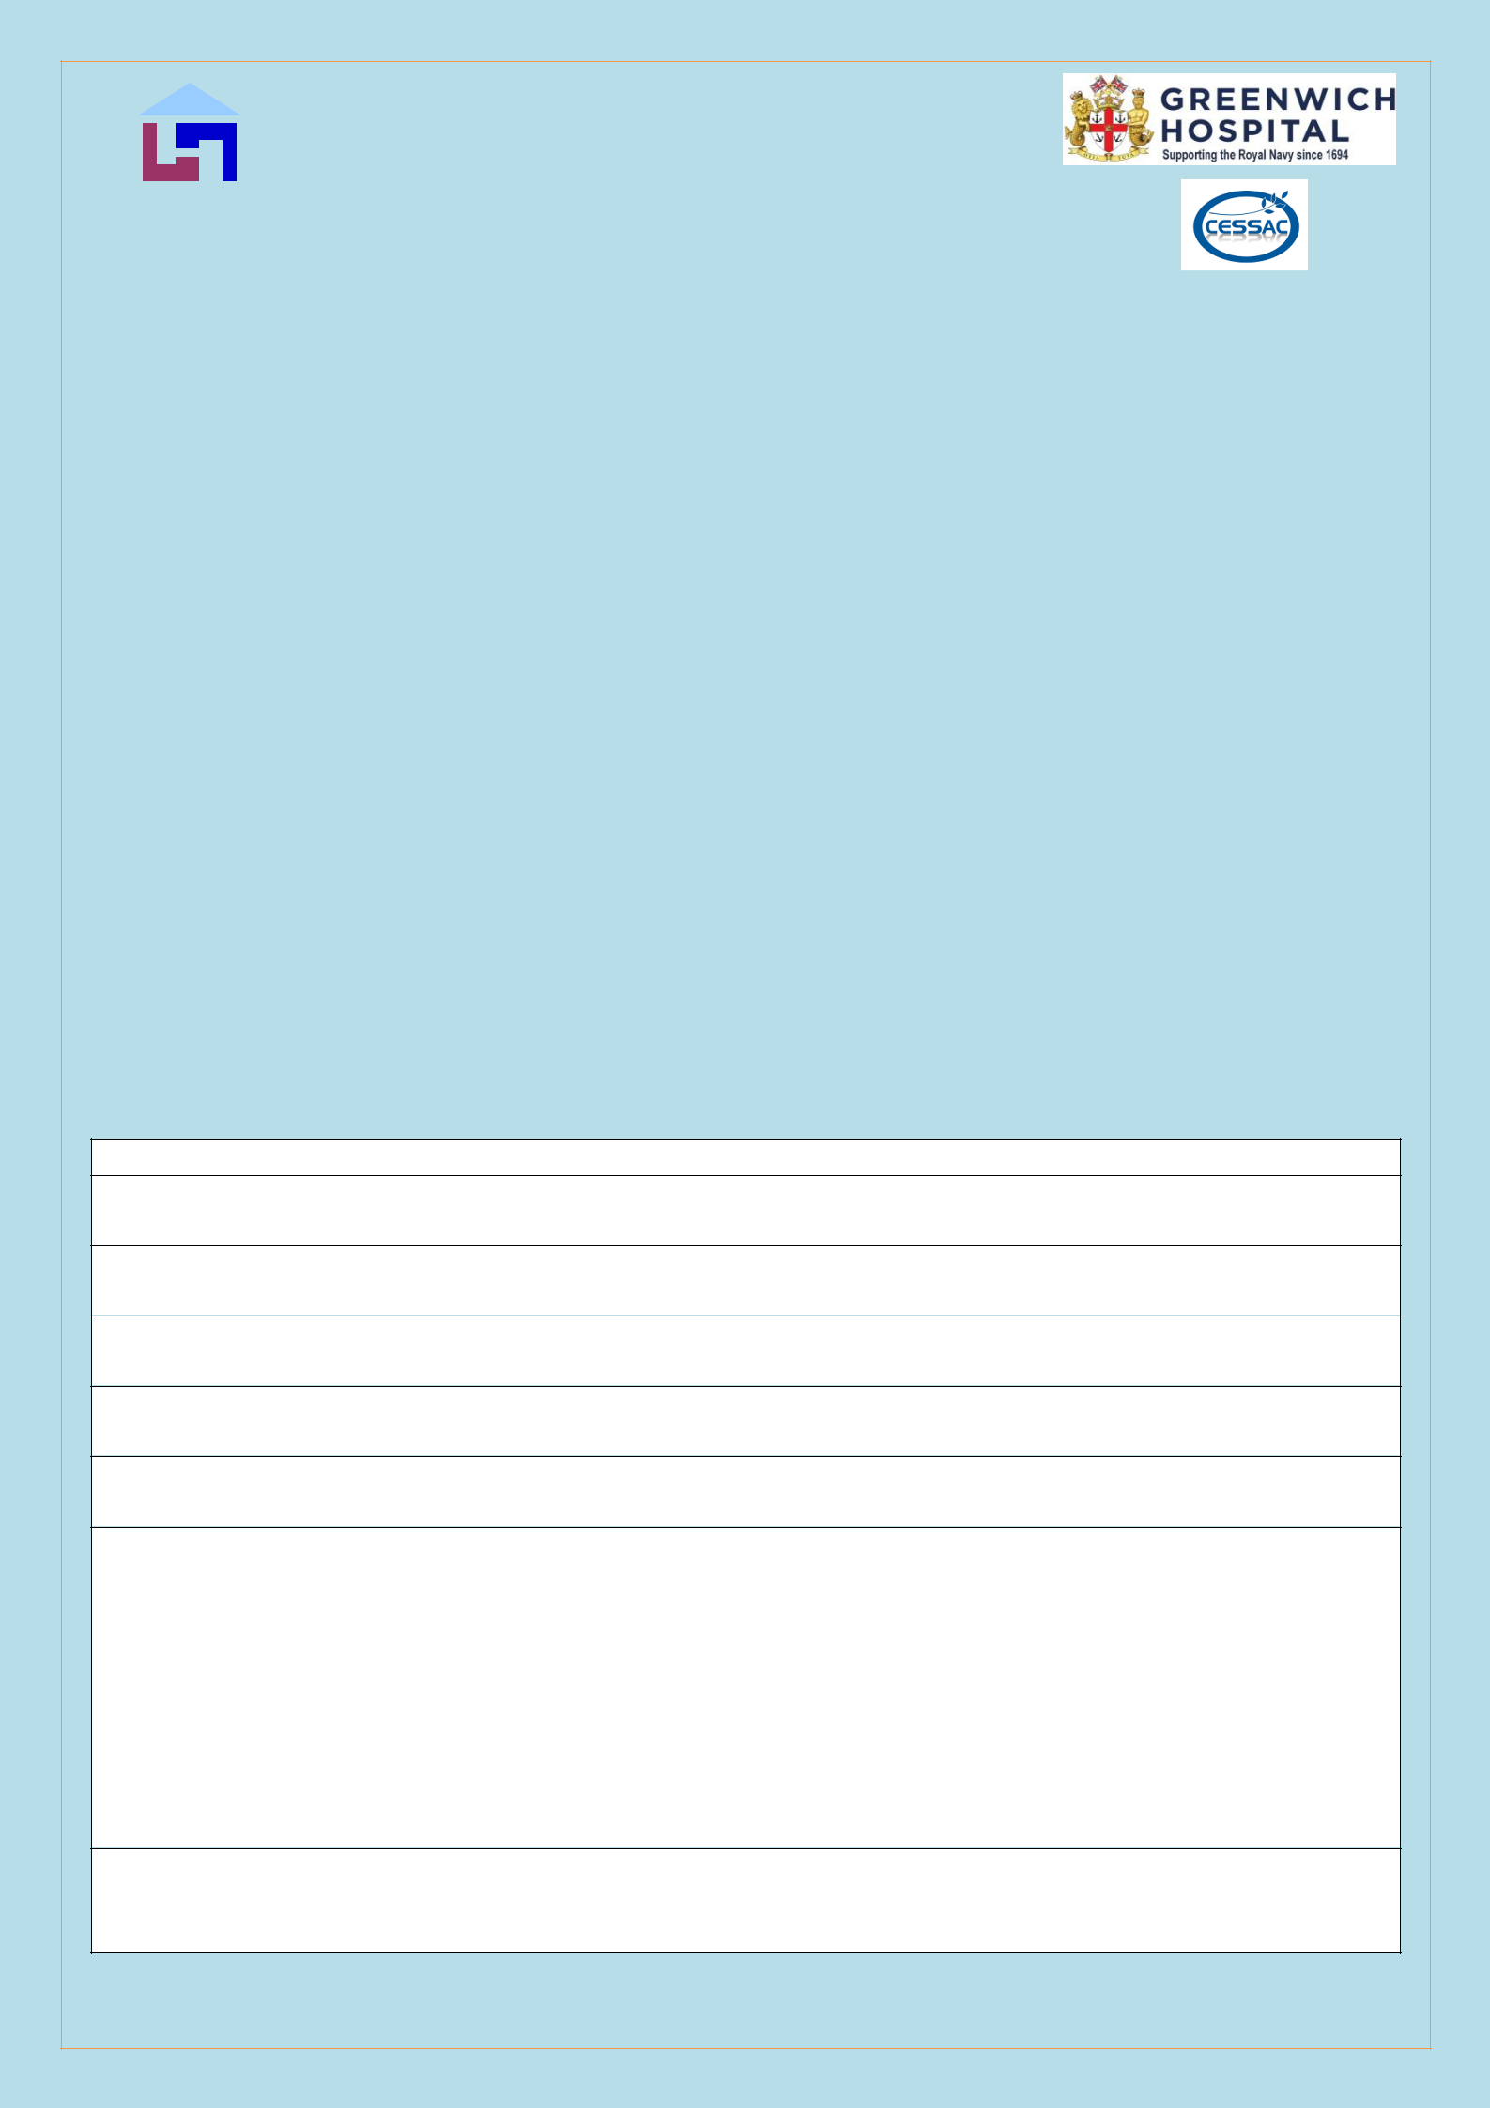
Sheltered Housing Application Form C20H

Confidential When Completed

This form should be completed by the applicant, whether applying for housing with CESSA Housing Association (CESSA HA) and/or with Greenwich Hospital (managed by CESSAC). Please use black ink and block capitals.

CESSA HA & CESSAC are committed to treating everyone fairly. To help us do this we need to know some details about you. Your answers will allow us to ensure you are eligible to apply and that your needs can be met as far as possible. See full Privacy statement at the end.

The Organisation’s sheltered accommodation is NOT Residential or Nursing Home care and only ‘good neighbour’ assistance is able to be provided during the working week. Therefore, Applicants must be capable of independent living at the outset.

Guidance Notes

- It is important to give as much information as possible on your current circumstances i.e. environment, neighbourhood, family support etc.

- If you are the widow/widower of a qualifying applicant, please give details of his/her service in H M Forces or MOD unless you yourself have qualifying service.

- If you own property it would be helpful to have an estimate of current value – This will not be a bar to qualifying, but you are expected to sell when taking up a tenancy.

- Note that Applicants who apply for a specific Scheme are not given higher preference than one who ticks the ‘any’ box.

APPLICANT DETAILS

- Applicant Name/s:

- Partner’s Name/s :

- Date of Birth DD/MM/YY:

- Date of Birth of Partner if applicable DD/MM/YY:

- Contact Telephone number/s:

- Contact Address (Include Postcode):

7. Email Address:
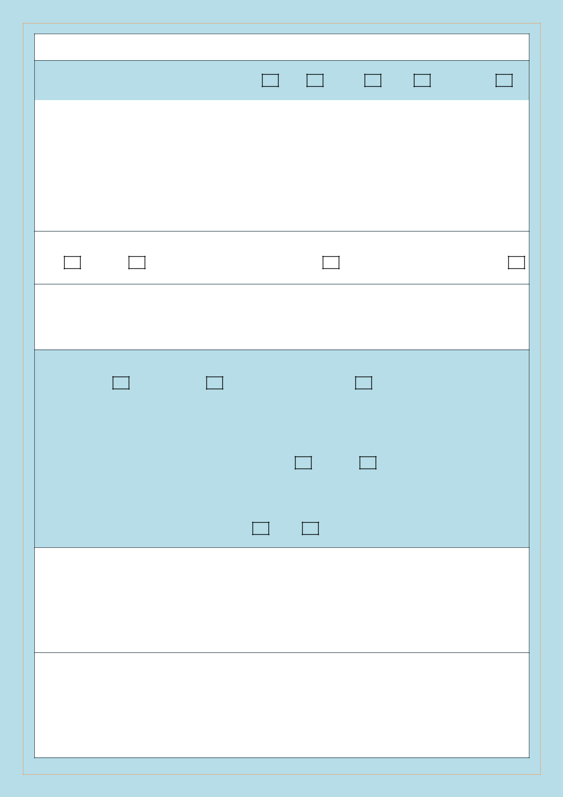
SERVICE HISTORY

 | 8. | Please tick one of the following: RN | RM | ARMY | RAF | MOD/RFA
 | 9. | Term of Service : Entry Date:- |  | Discharge Date:-
No of Years:-

N.B. Documentary evidence of Service will be required at the interview stage. Offer of accommodation cannot proceed if evidence cannot be produced. Examples of evidence are: Service record or book, Marriage Certificate, Service letters in your name. Photographs alone cannot be accepted as evidence.

10. Who Qualifies as Ex Service?
Self | Partner | Parent (not Greenwich Hospital) | Child (not Greenwich Hospital)

CURRENT HOUSING DETAILS

Note: Proof of “Right To Rent” must be shown at interview. This can be in the form of your Birth Certificate, Passport or Right of Residency Permit (from the Home Office).

 | 11. What type of property are you currently living in?
 | House | Flat | Other (Please state)
 | 12. How many bedrooms do you have?
 | 13. Do you share a home with relatives? |  |  | Yes | No
 | Please comment:
 | 14. Do you have use of a lift? |  | Yes | No
15. If you rent, what type of tenancy do you hold?

16. And who is your Landlord/housing provider e.g. name of Housing Association?

17. What is your current rent?

 | £ | Week/Month (Delete as appropriate)

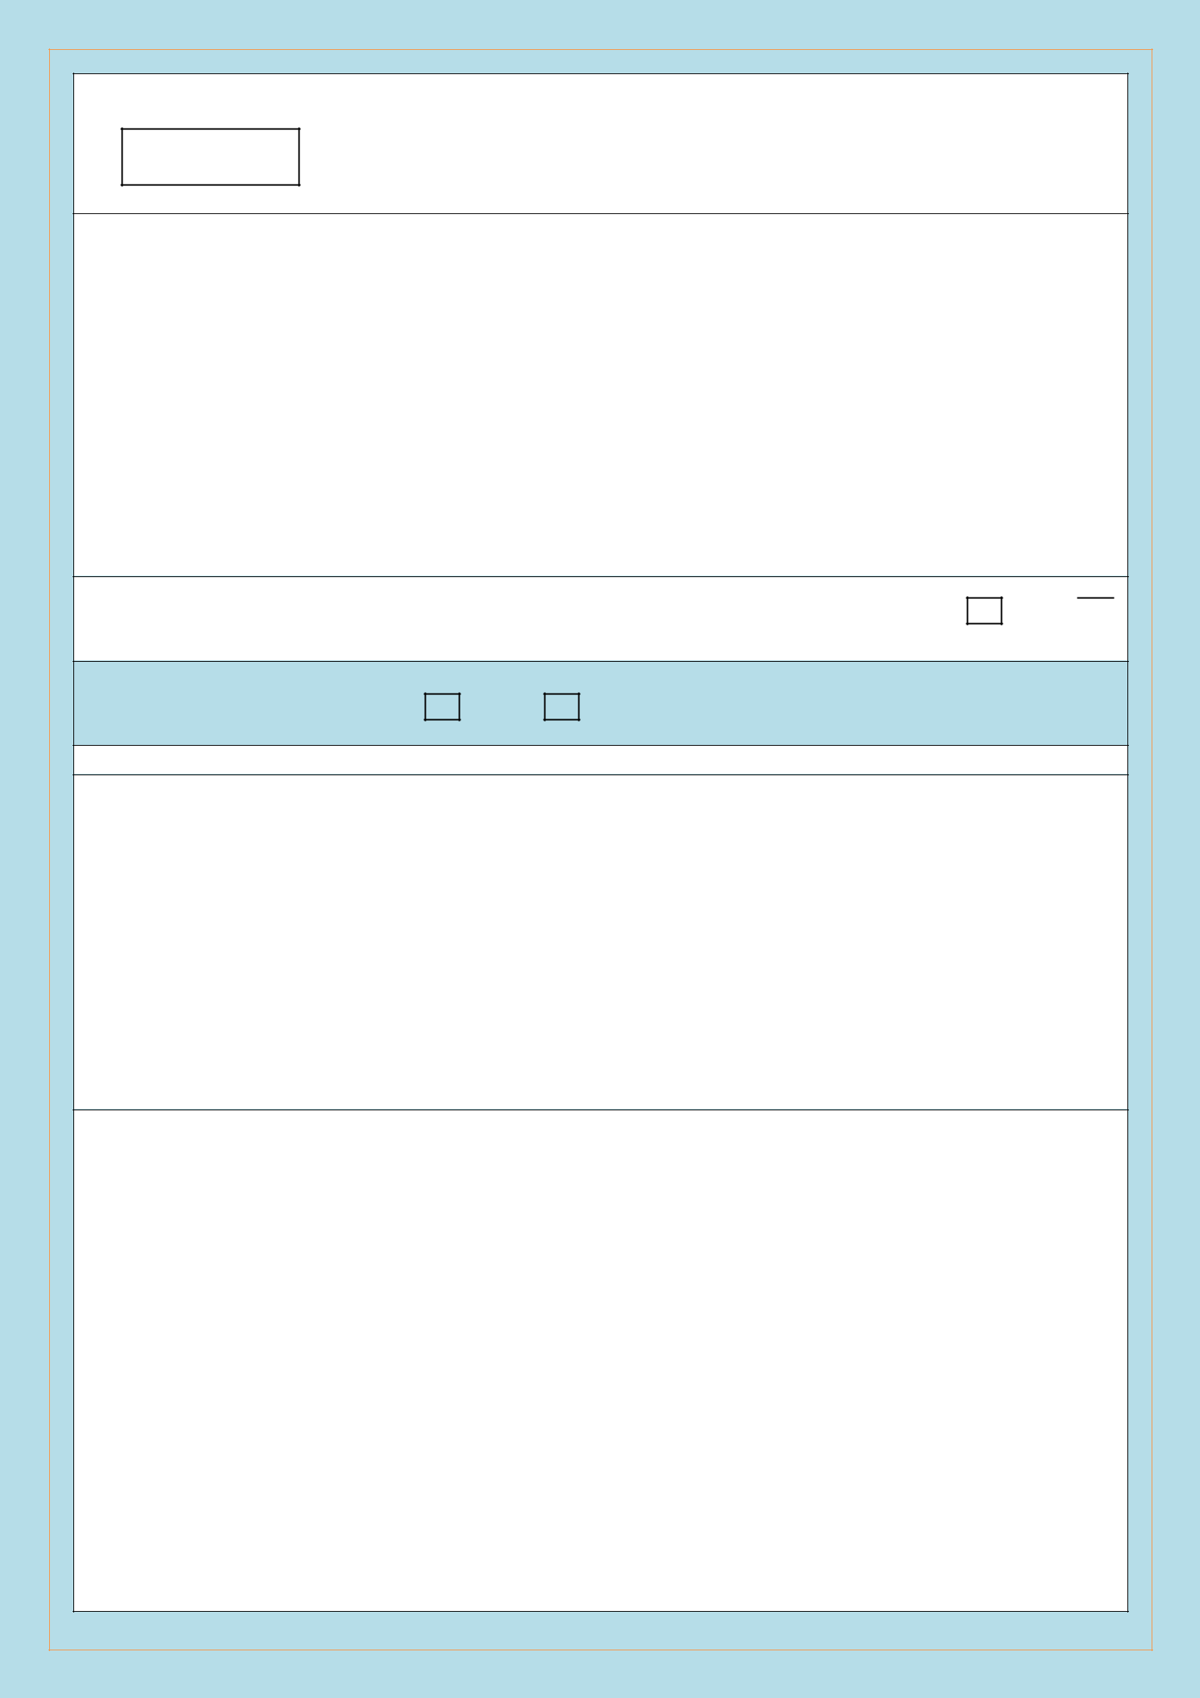
18. If you are a Home Owner what is the current market value of your property?

£

- Please state any problems with current property i.e. Maintenance or Anti social behaviour etc.

20. Do you or your Partner use a mobility scooter? No |  | Self |  | Partner

Both 

 | 21. Do you own a car? Yes | No

FAMILY DETAILS

- Please state the name and address and contact details of your Next of Kin and their relationship to you e.g. Son, Daughter etc.

23. Explain briefly what (if any) family support you may have.

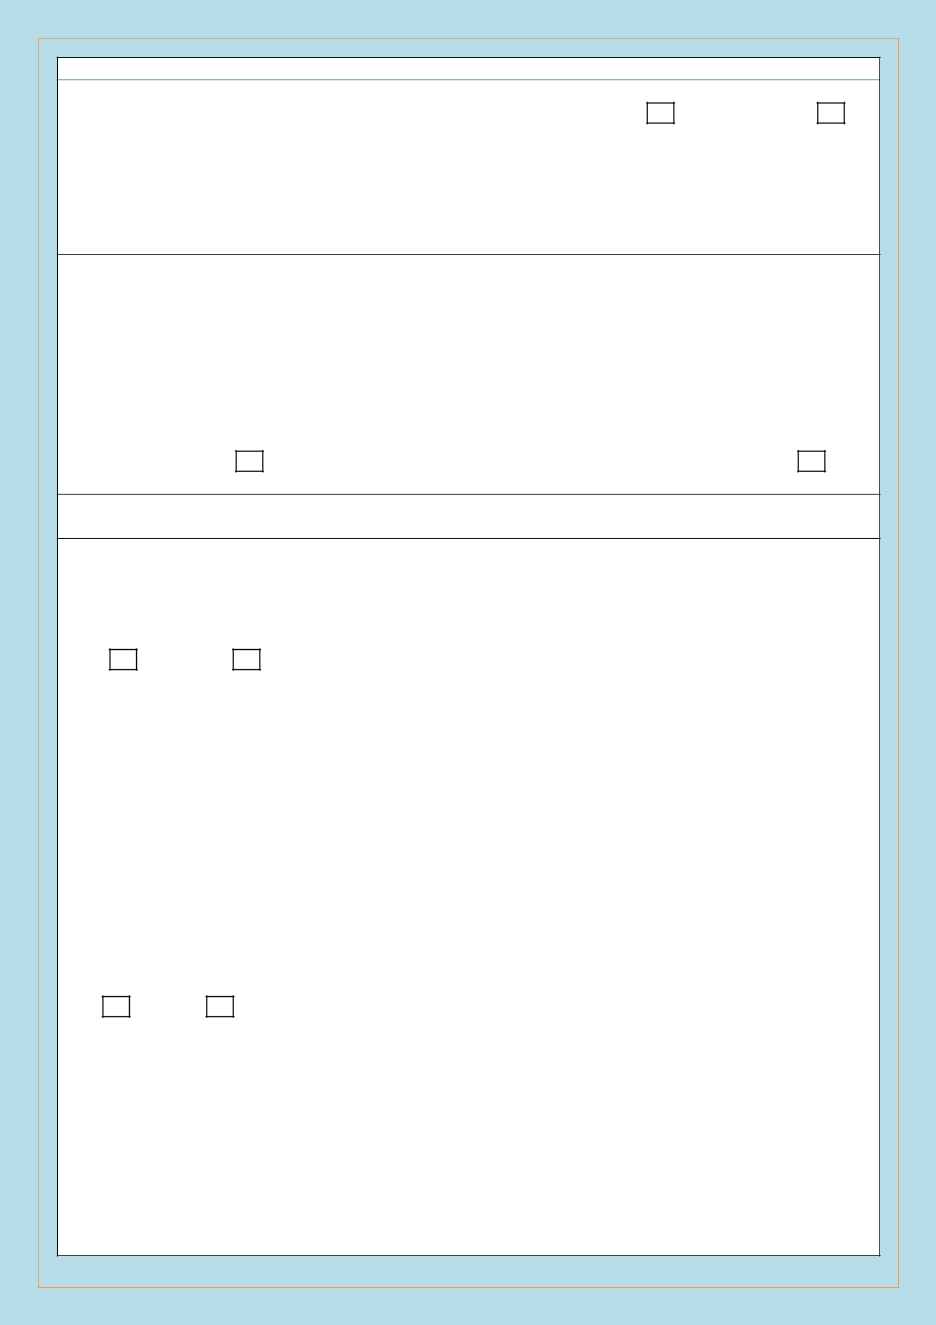
TYPE OF ACCOMMODATION YOU ARE APPLYING FOR & WHERE

24. Studio |  | 1 person flat |  | 2 person flat (Couples only)

Disability Flat

A studio flat is a flat where the bed area is part of the living space. All have their own kitchen and bathroom. Dhekelia Court is our only scheme with studio flats for single tenants.

N.B. We operate a ‘no pets’ policy for all our accommodation.

25. Location preference: Any |  | Portsmouth |  | Gosport |  | Fareham
If Portsmouth please state scheme preference/s (See accompanying leaflet for scheme details):

Ex RN,RM,WRNS only

Saltash (Cornwall)

London (Greenwich) |  | Greenwich Court (Portsmouth)

Health and Disability

- Do you consider yourself or partner to have a disability as defined in the Equality Act 2010? The Act defines disability as: “a Physical or mental impairment which has substantial and long-term effects on a person’s ability to carry out normal day to day activities”.

Yes

No

If ‘Yes’ who is affected and how?

- Do you or your Partner suffer from ill health or disability that affects their ability to manage in their present home?

Yes |  | No

If ‘Yes’ who is affected and how?

Any other useful information you feel may help your application:


I understand the following:

By completing, signing and sending this application, I am providing my consent for the information in it (some of which is sensitive e.g. health information) to be collected by CESSA HA (or CESSAC) as data controller. Consent is the legal basis under which my information can be processed in order to determine my eligibility for the sheltered housing requested and to try and ensure appropriate accommodation might be offered. I understand that if I obtain accommodation by giving inaccurate information, CESSA HA (or CESSAC) may take legal action to recover the property.

I can withdraw consent for my application to be held at any time before a tenancy is accepted and the information would then be destroyed. Otherwise, the application form will be held confidentially in the registered office for 3 years, with key details logged electronically, to enable consideration for any appropriate vacancies that occur. If any of my material information changes, especially of my address or telephone number, I should keep the office updated. I will also need to contact the office if I have not accepted a tenancy within 3 years but wish to remain under consideration.

I note that: No other action will be undertaken with my data (sharing etc) without further notification, e.g. until a tenancy interview is offered. If an interview is offered, I agree that CESSA HA (or CESSAC) may contact any organisation it needs to check information I have provided. I understand that further information may be requested at interview, which may inform a decision (by either party) on whether to proceed. If a tenancy is subsequently offered and accepted, then a new privacy notice would be provided including a different legal basis for holding some of the information thereafter and how it would then be processed..

If I have any concern about how my personal data is used, I should first complain to the office. If not satisfied I can also complain to the UK Information Commissioner’s Office (ICO) at https://ico.org.uk/.

I declare that the information I have given on this form is correct and complete.

Signed (Your Signature) Date

To help us to assess the effectiveness of our marketing strategy, please indicate below where you heard about us.

Leaflet

Other

Magazine |  |  | Newspaper |  | Internet
Please give details |  |  | ........................................................................................

If you ticked ‘Magazine’ or ‘Newspaper’ please tell us which one………………………………………


Please return your completed form to our Registered Offices at:

CESSA HA (CESSAC for Greenwich Hospital flats), 1 Shakespeare Terrace, 126 High Street, Portsmouth, PO1 2RH

The CESSA element of both titles stands for ‘Church of England, Soldiers, Sailors and Airman’s’, neither of which is religious in operation. CESSA HA is a charitable Housing Association registered with the Homes & Communities Agency (L0104), while CESSAC is registered with the Charity Commission, No 226684.

Tel: 02392 829319 Website: www.cessaha.co.uk

If you require confirmation of receipt of this application, a stamped addressed envelope should be enclosed with the correct postage applied.

Continue any useful information here:

Updated: Oct 2021


EQUALITY AND DIVERSITY MONITORING FORM

All applicants for CESSA HA (& CESSAC) accommodation will be treated equally. In order that we can monitor our progress towards equal opportunities, we ask for information about ethnic origin and sexuality. However, it will be treated in strict confidence and detached from the application prior to any assessment being made about offering a tenancy.

ETHNIC ORIGIN

 | 1. Please state your ethnic origin. Tick as appropriate. |  |  | Prefer not to state
 |  | Ethnic Origin |  | Self | Partner
 |  | White British
 |  | White Irish
 |  | Any other White background
 |  | Black or Black British: Black African
 |  | Black or Black British: Black
 |  | Caribbean
 |  | Any other Black background
 |  | Asian or Asian British: Indian
 |  | Asian or Asian British: Pakistani
 |  | Asian or Asian British: Bangladeshi
 |  | Any other Asian Background
 |  | Mixed White and Black African
 |  | Mixed White and Black Caribbean
 |  | Mixed White and Asian
 |  | Any other Mixed background
 |  | Chinese
 |  | Other Ethnic Origin (Please State):
 | YOUR SEXUALITY
1. Please tick the relevant box for you and your Partner:

 | SEXUALITY | YOU | PARTNER
 | Heterosexual
 | Gay
 | Lesbian
 | Bisexual
 | Transgender
 | Prefer not to state

Privacy Notice

The key elements of the privacy notice on the previous page also apply to this one, except that this information is only collected for the reasons stated at the top of the form. Accordingly, after recording the anonymised data, this page will be destroyed.

